VotingStationType

The Data type are the same

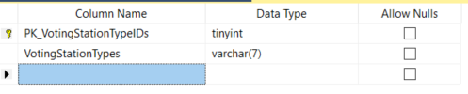

Rows retrieved 2 rows

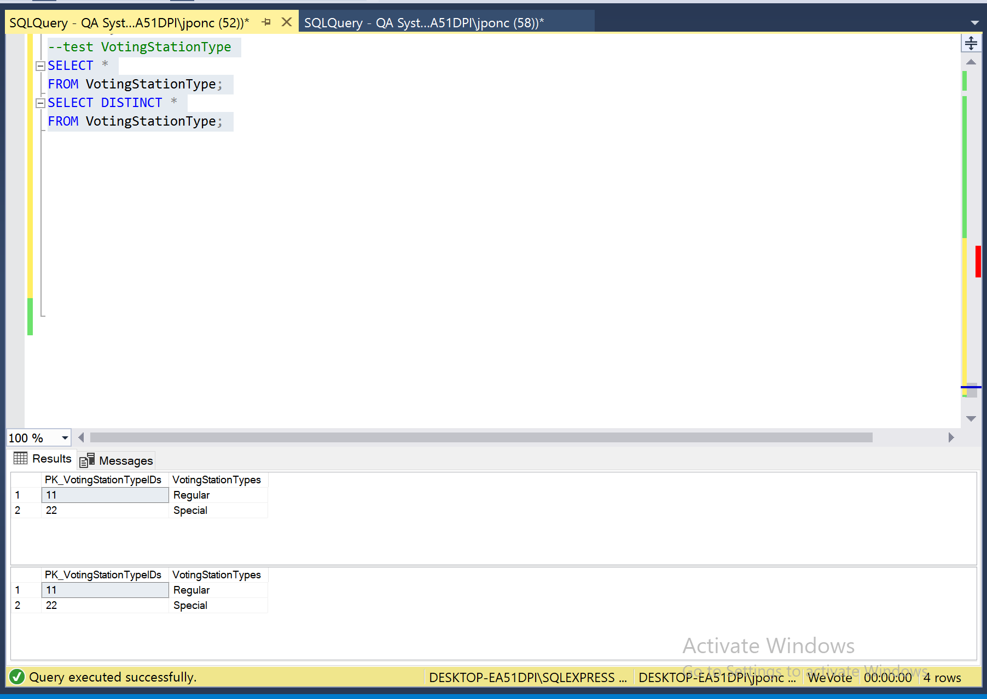

Data Manipulation

Primary Key related to other table and with Foreign Key

Executing

“ Begin Transaction Delete Top(1) from VotingStationType ROLLBACK ”

Error “The DELETE statement conflicted with the REFERENCE constraint "FK2_VotingStationIDs". The conflict occurred in database "WeVote", table "dbo.VoteCounts", column 'FK2_VotingStationIDs'” was generated.

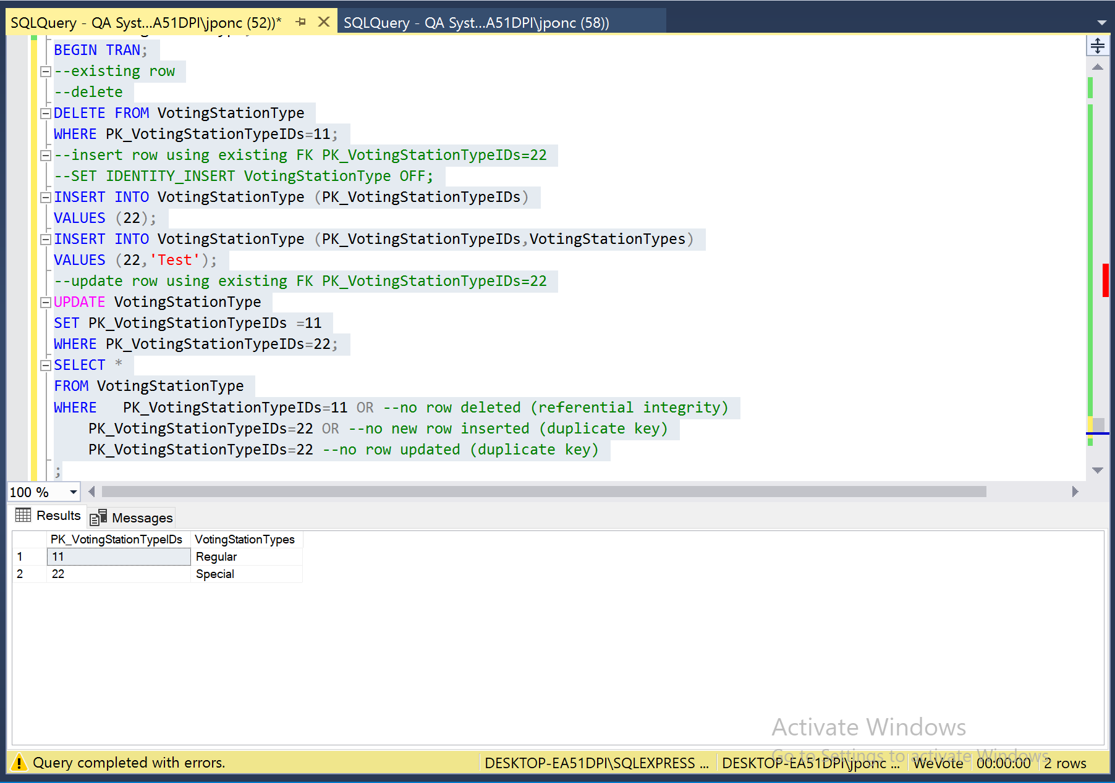

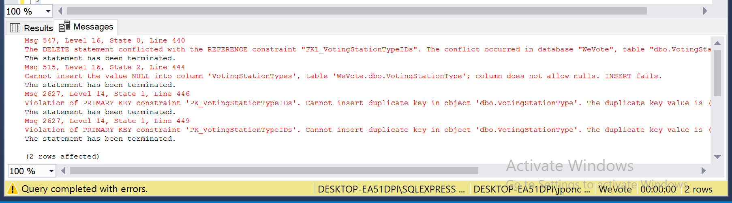

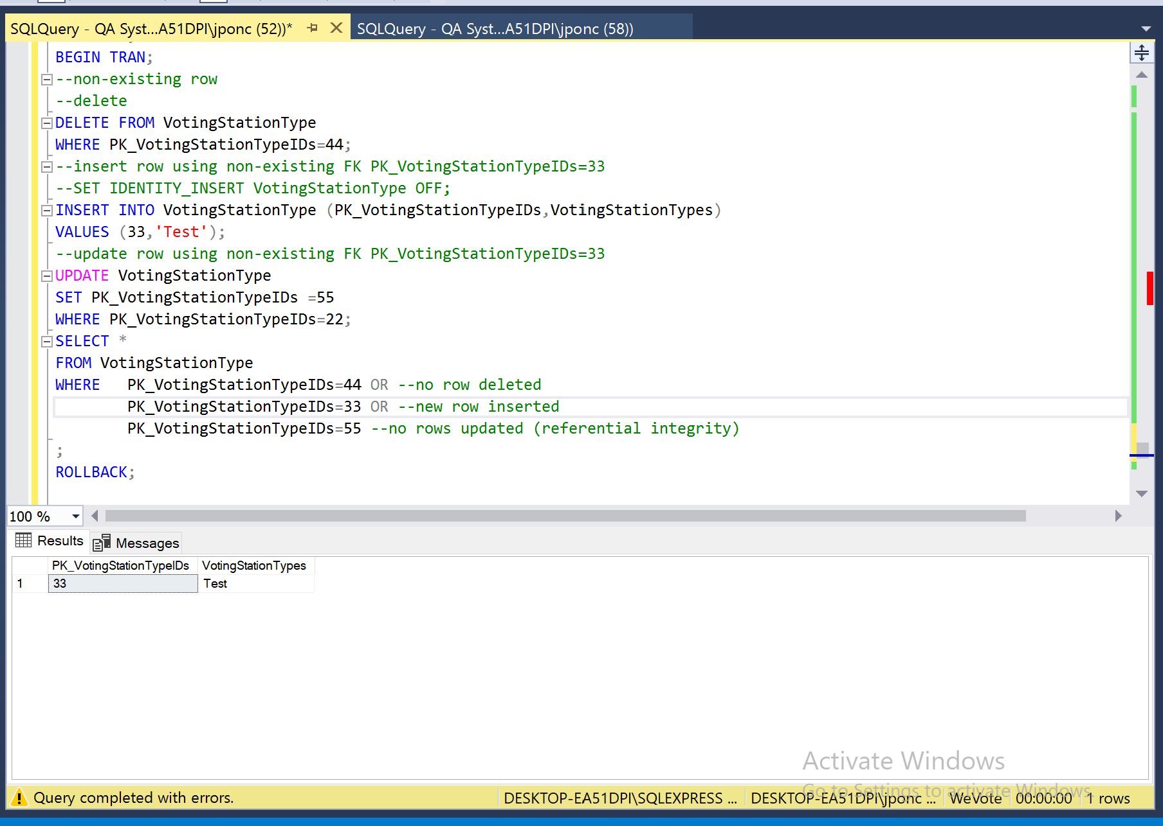

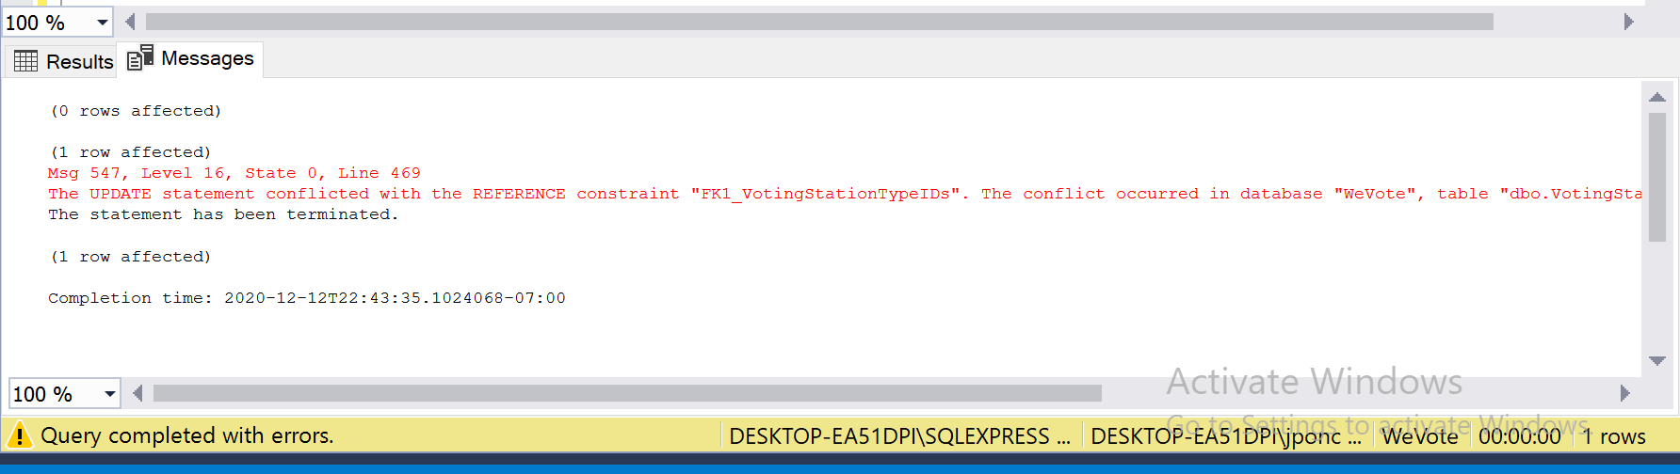

## For table VotingStationtype:

The fig below show the column that allow Nulls



Executing

“ Begin Transaction Delete Top(1) from VotingStationType ROLLBACK Begin Transaction

insert into VotingStationtype (PK_VotingStationTypeIDs)

Values('1')

select * from VotingStationtype

where PK_VotingStationTypeIDs =1 ”

Error “Cannot insert the value NULL into column 'VotingStationTypes', table 'WeVote.dbo.VotingStationType'; column does not allow nulls. INSERT fails.

” was generated because null are not allowed in VotingStationTypes

**No check constraint in Table VotingStationType**